**Day 19 Task: Docker for DevOps Engineers**

**Task-1**

* Create a multi-container docker-compose file which will bring *UP* and bring *DOWN* containers in a single shot ( Example - Create application and database container )

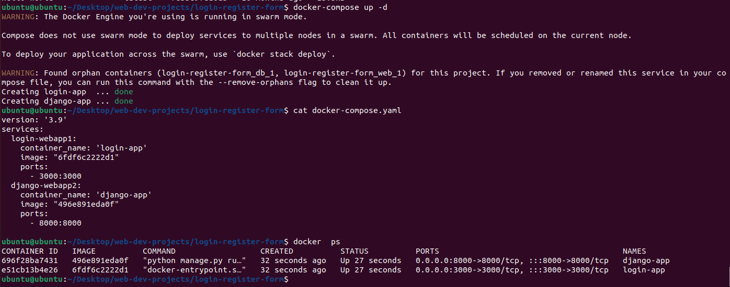

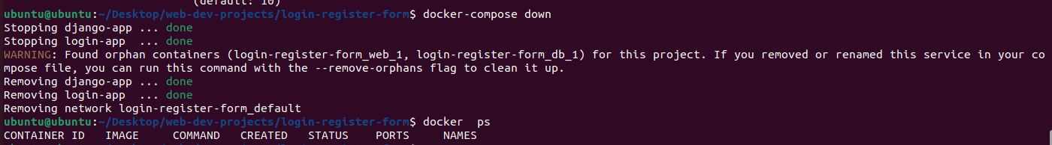



**Task-2**

* Learn how to use Docker Volumes and Named Volumes to share files and directories between multiple containers.
* Create two or more containers that read and write data to the same volume using the docker run --mount command.



* Verify that the data is the same in all containers by using the docker exec command to run commands inside each container.
* Use the docker volume ls command to list all volumes and docker volume rm command to remove the volume when you're done.